# COMP1562, Lab #6 Scheduling

|  |  |  |  |
| --- | --- | --- | --- |
| Lecturer | **Mariusz Pelc** | Phone | **020 83318588** |
| Office | **QM366** | e-mail address | [**m.pelc@gre.ac.uk**](mailto:m.pelc@gre.ac.uk) |
| Office hours | **Mon 4-5pm, Wed 9-10pm** |  |  |

**(by M. Pelc and K. McManus)**

**Description:**

**This exercise is mainly focused on Linux introduction to Linux shell programming.**

**Learning Outcomes:**

**Students will be able to understand differences between various scheduling algorithms.**

**EXERCISES**

1. You are supposed to open document **Operating Systems Workbench Tutorial** on Moodle and simulate all described introductory exercises. Use **Operating System Workbench program** provided by dr Richard Anthony (also available on Moodle) and provide screenshots showing how the simulations ended. The algorithms you need to simulate are:
2. FCFS1
3. SJF 1
4. FCFS2

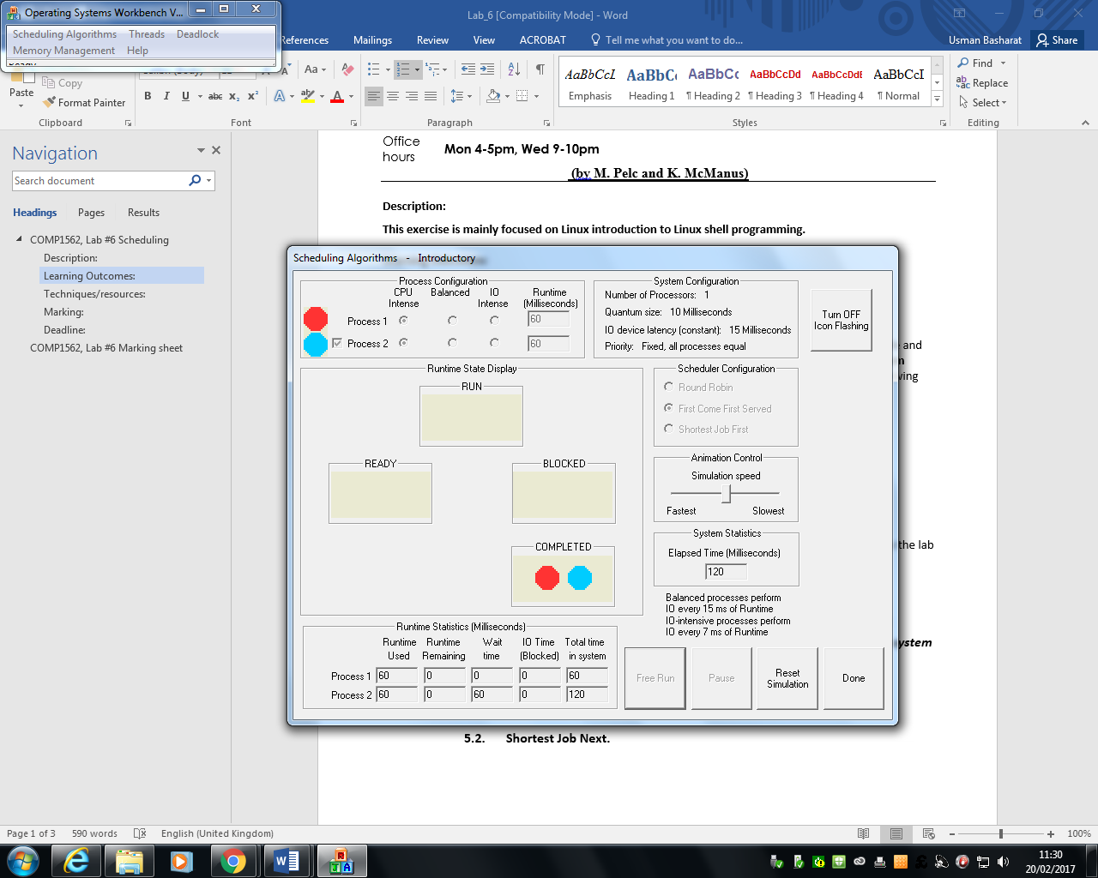

1. FCFS3

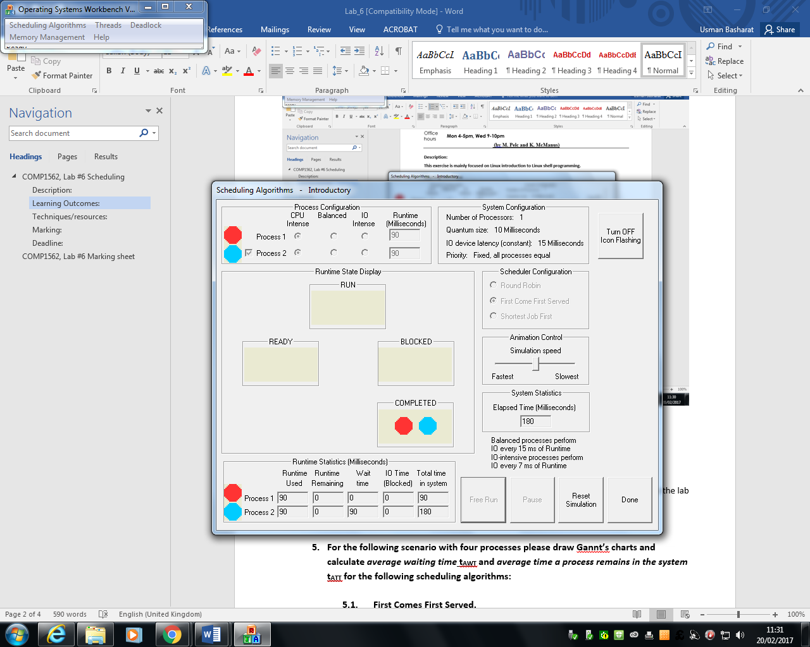

1. SJF2

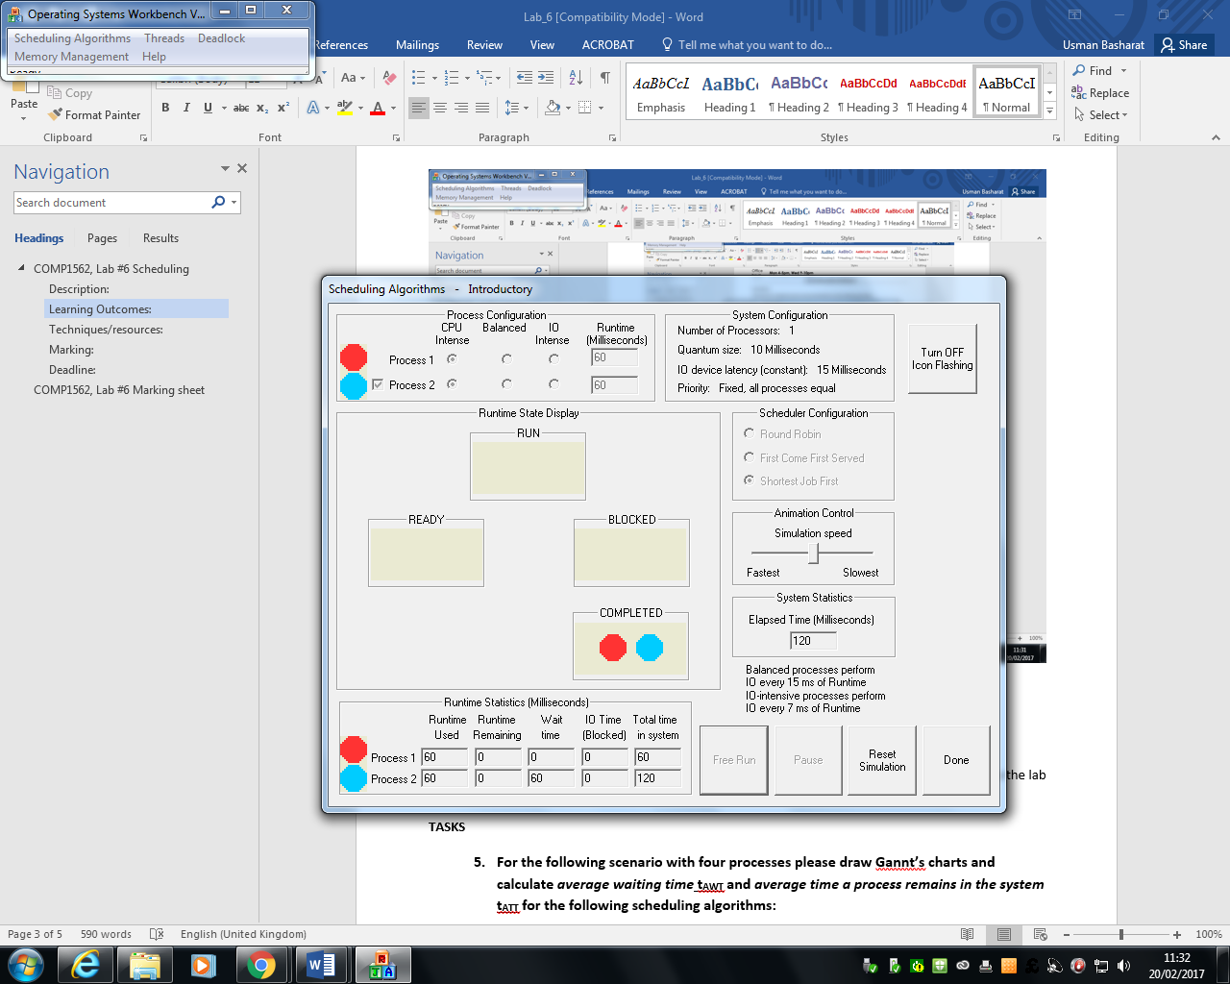

1. RR1

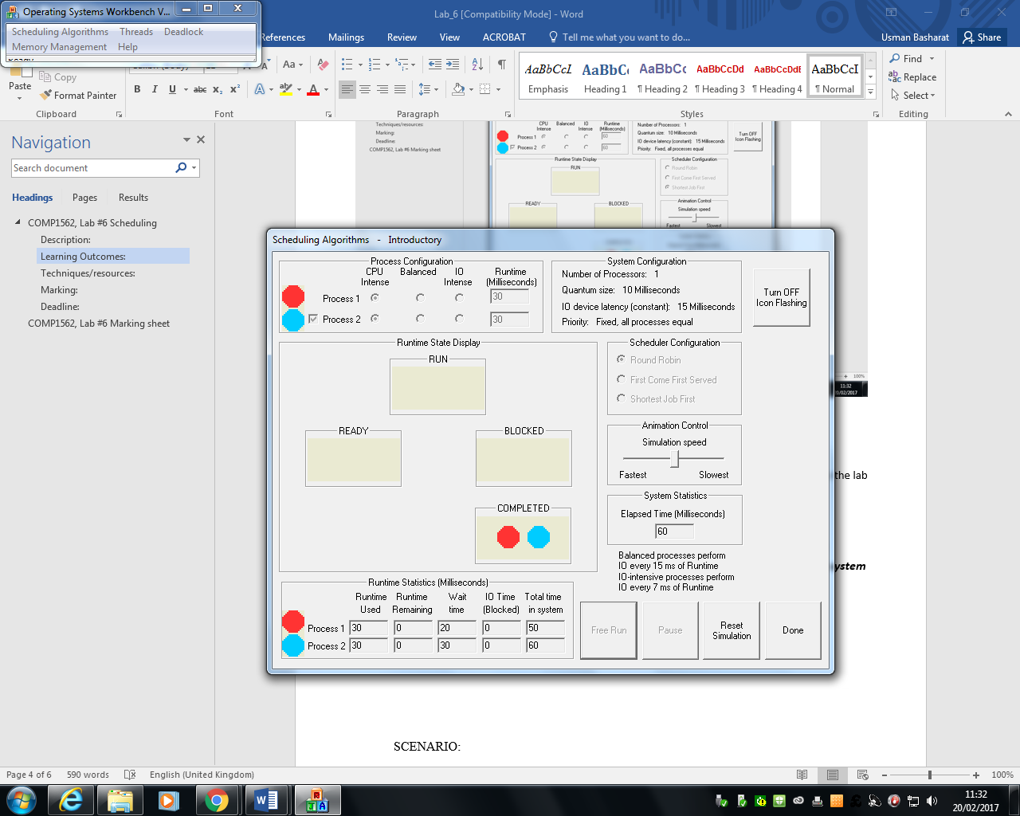

1. RR2

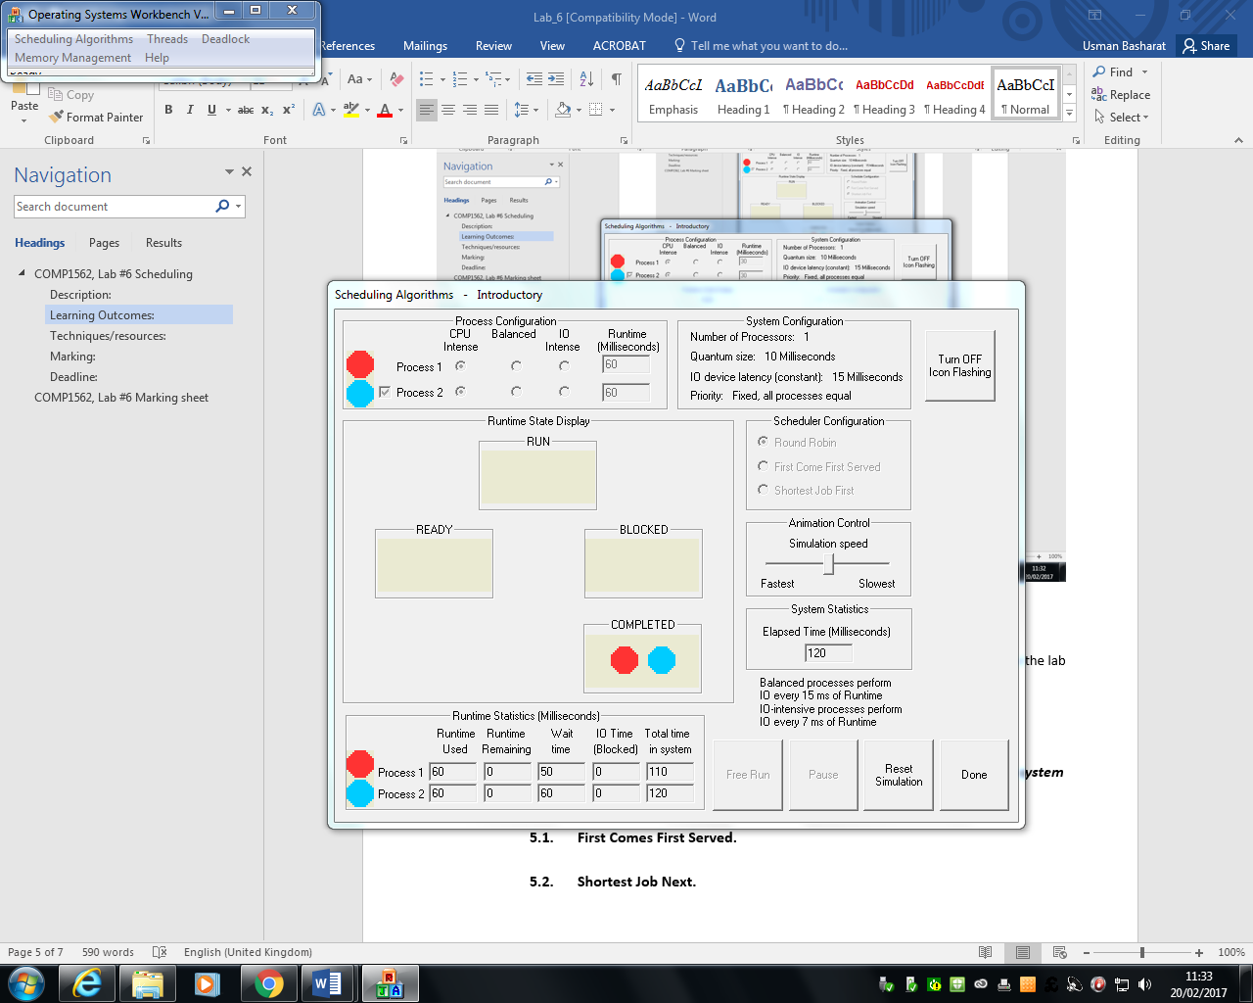

1. RR3

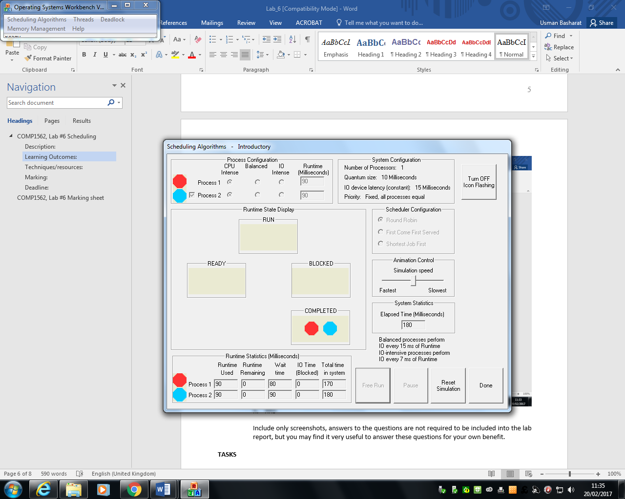

Include only screenshots, answers to the questions are not required to be included into the lab report, but you may find it very useful to answer these questions for your own benefit.

**TASKS**

1. **For the following scenario with four processes please draw Gannt’s charts and calculate *average waiting time* tAWT and *average time a process remains in the system* tATT for the following scheduling algorithms:**
   1. **First Comes First Served.**

* 1. **Shortest Job Next.**

SCENARIO:

|  |  |  |
| --- | --- | --- |
| **Process** | **Arrival Time [ms]** | **Service Time [ms]** |
| P1 | 0 | 11 |
| P2 | 2 | 8 |
| P3 | 4 | 4 |
| P4 | 6 | 6 |

**For the purpose of marking with scriptcheck you’ll need to use “w” to indicate a process is waiting, “r” to indicate a process is running and “-“ to indicate a process has not yet arrived to the system, For example, the below Gannt chart:**

**rrrr**

-wwwrrrrrr

---wwwwwwwrrrrrrrr

will reflects scenario:

|  |  |  |
| --- | --- | --- |
| **Process** | **Arrival Time [ms]** | **Service Time [ms]** |
| P1 | 0 | 4 |
| P2 | 1 | 6 |
| P3 | 3 | 8 |

**Techniques/resources:**

**Solution of all the above tasks does not require anything except scriptcheck system to enter solutions and calculator to for calculations.**

**Marking:**

**The solutions will be marked in the range 0-100%.**

**Deadline:**

**The solutions should be delivered within one week from the lab date.**

# COMP1562, Lab #6 Marking sheet

Peer mark for group: [provide group ID here]

|  |  |  |  |  |
| --- | --- | --- | --- | --- |
| **Exerc** | **Status** | **Description** | | |
| ***1a*** |  | ***4 marks for each screenshot plus 4 marks extra if all exercises are completed.*** | | |
| ***1b*** |  |  | | |
| ***1c*** |  |  | | |
| ***1d*** |  |  | | |
| ***1e*** |  |  | | |
| ***1f*** |  |  | | |
| ***1g*** |  |  | | |
| ***1h*** |  |  | | |
| ***Score from AMS*** |  | | | |
| ***Name*** | |  | ***ID*** |  |
| ***Name*** | |  | ***ID*** |  |
| ***Name*** | |  | ***ID*** |  |
| ***Name*** | |  | ***ID*** |  |
| ***Name*** | |  | ***ID*** |  |
| **Exercise part mark** | |  | | |
| **Date** | |  | | |
| **Signature** | |  | | |

The marking sheet should be filled in by designated member of the marking group (make sure that each group member will mark at least one upload during the term time) then dated and then signed. After that it should be scanned / photographed, then copy-pasted / inserted into WORD document saved into a file named according to the convention:

**GID_TID_MarkingSheet.docx**

where **GID** is the marked group ID and the **TID** is the task that you marked.

The document should be uploaded to the scriptcheck.cms.gre.ac.uk server using FTP client. The username to FTP service on the scriptcheck.cms.gre.ac.uk server is ‘peerm’ and the password is ‘!1peerm’. All groups will be uploading into the same directory so please make sure you apply the file naming convention. Also, after uploading the file to the server you will not be able to delete the file (the server allows uploading, but not deleting files).

**The marked group (when requested) should provide the marking person with the uploaded work that is subject of marking (electronic version or printout) and notify the marking person what was the group score for the tasks awarted by the AMS.**

**Please mind that you should NOT provide your solutions to the marking group before deadline for uploading this lab results.**